CARI Study – XLSForms
Conditions are already included in the forms to pull from the sample list into the HH IDs related fields, and they are as below:
minimal autocomplete search('sample_list','matches','ADMIN1Name', ${ADMIN1Name},'eligible','1')
pulldata('sample_list', 'hhname', 'Uid', ${HHID})
Additionally, please ensure that you do not change this setting under the ‘choices’ tab of the form.
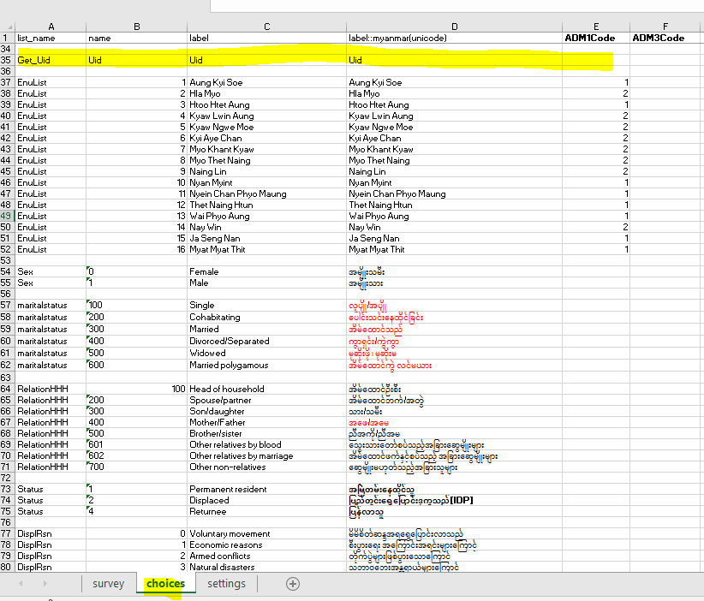
CARI Study – sampling list
Please ensure the following in the sampling list file:
- Name the file ‘sample_list’
- the label name in the sample_list file must follow the Myanmar example for the labels present in the above conditions (i.e., ADMIN1Name, eligible) in numeric values – see in green below
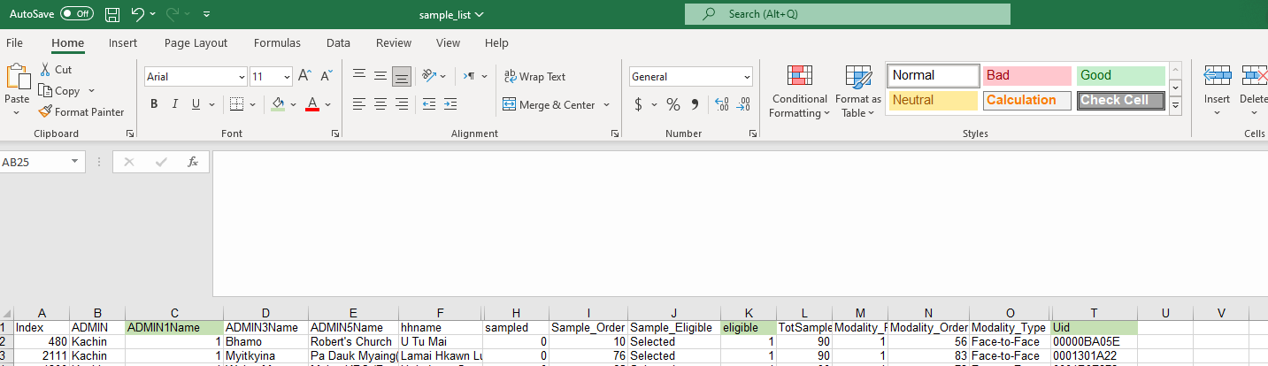
- unique IDs (i.e. Uid) must consider the 10 digits for long modules and 9 for short modules in the F2F form, while 8 digits for long modules and 7 for short modules in the remote form. This means one sampling list file must be uploaded for the relevant form.
- covert the file into CSV
Uploading the sampling file to MODA
To upload the ‘sample_list’ file onto MODA, please follow the below steps.
IMPORTANT: when you delete a MODA form, you will delete the sample list file as well.
1: click the form link
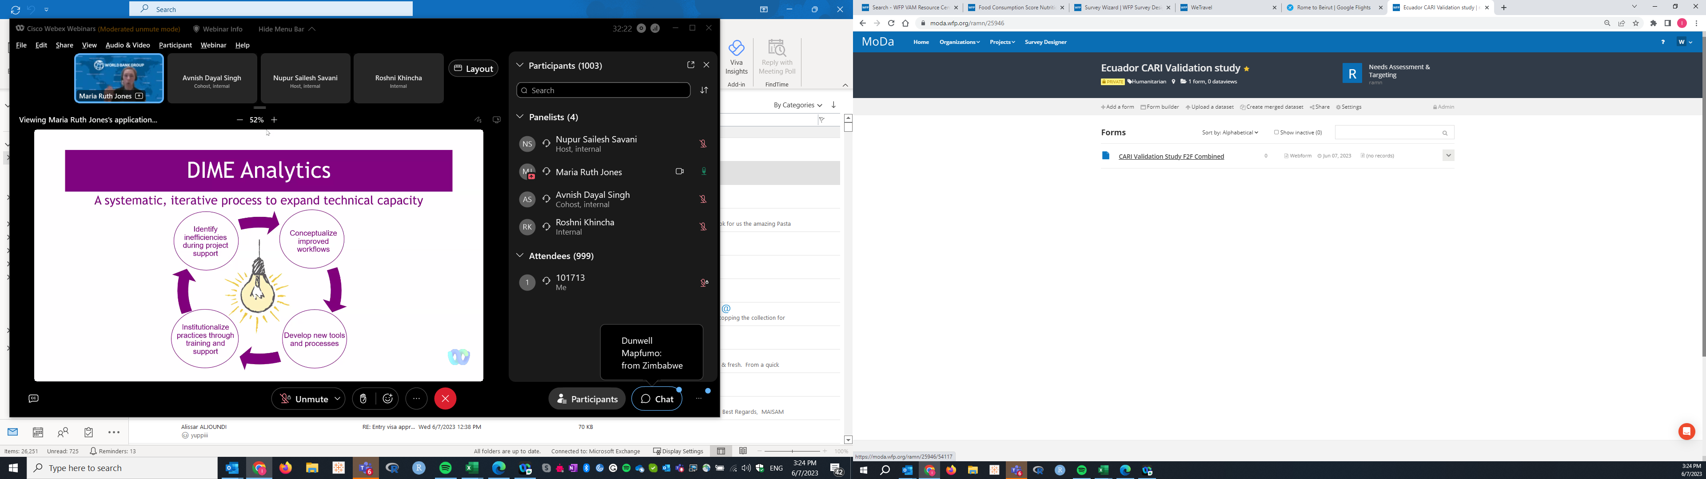
2: Go to settings
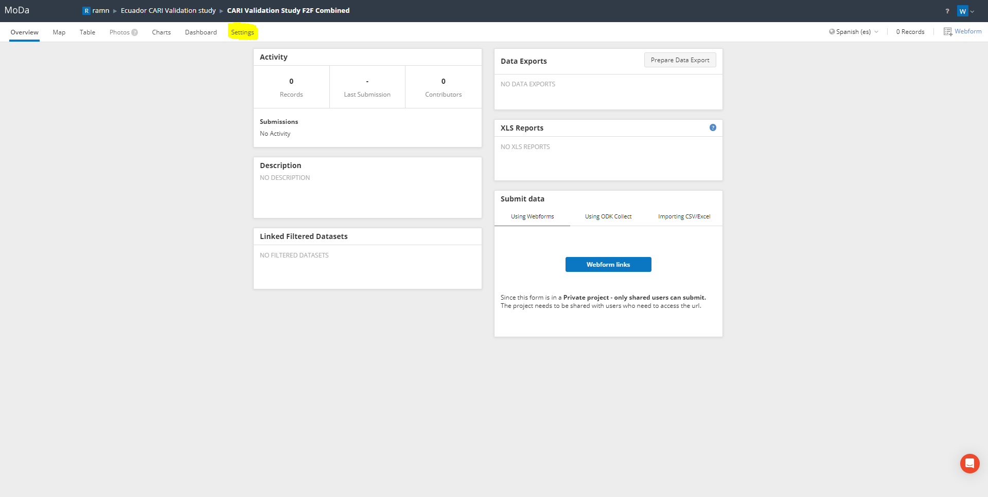
3: To upload the sample_list file, then go to select file to upload and then click the ‘upload’ button.
